Assessment Team Report

The Assessment Team comprised of following three members visited the Department of Agronomy in order to assess its M.Sc (Hons) degree program and conducted a meeting on September 23, 2011:

- Prof. Dr. Amanullah Jan (Sr.) Convener AT
- Dr.Muhammad Arif AT Member
- Mr. Fazal Munsif External AT Member

The above team in its meeting with the Chairman and Dean identified the following Strength and Weaknesses of the M.Sc (Hons) degree program:

Strengths:

- The department has fifteen (15) well-qualified faculty members, amongst them thirteen (13) faculty members are Ph.D holders and all Ph.D holders have completed Post Doc from advance countries of the world.

- The department follows strict merit to enroll students not on basis of first come first served basis.

- The department currently has number of research projects on its credit.

Weaknesses:

- Lack of supporting staff.

- Space is also one of the major problems for both students and staff.

- No departmental seminar room.

- No trained lab technicians.

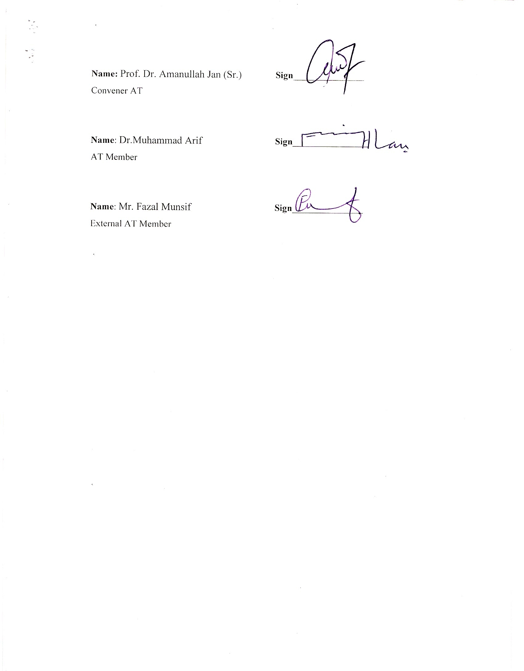

Name: Prof. Dr. Amanullah Jan (Sr.) Sign_______________
Convener AT

Name: Dr.Muhammad Arif Sign________________
AT Member

Name: Mr. Fazal Munsif Sign_______________
External AT Member

